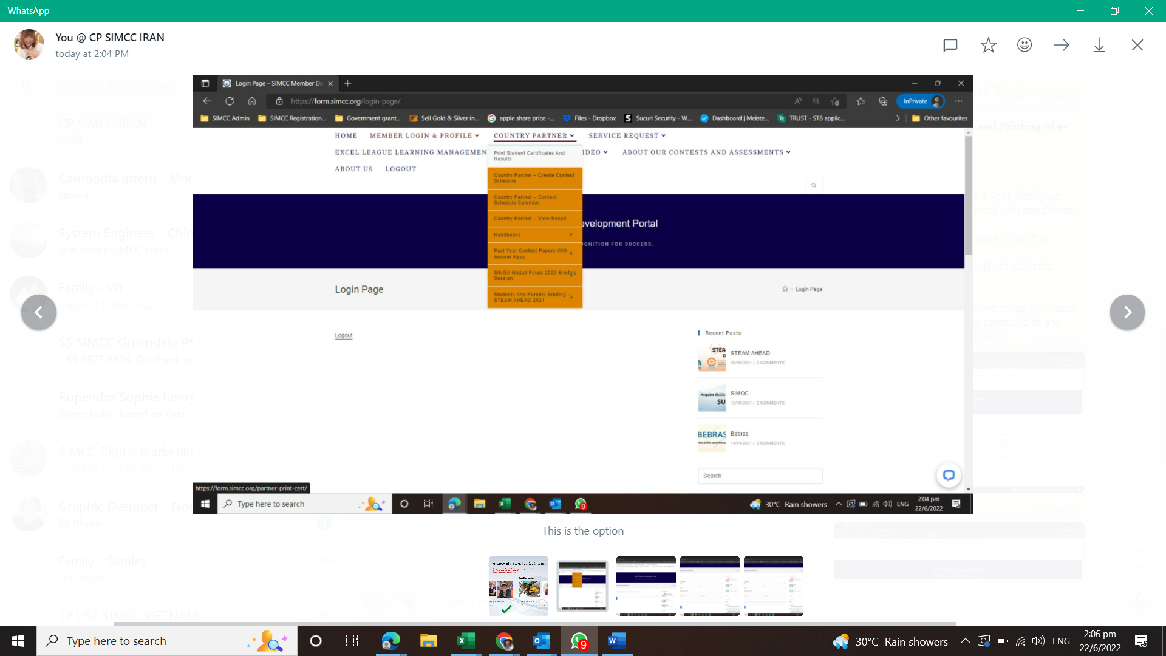
Login to MDP and select the option from the menu.
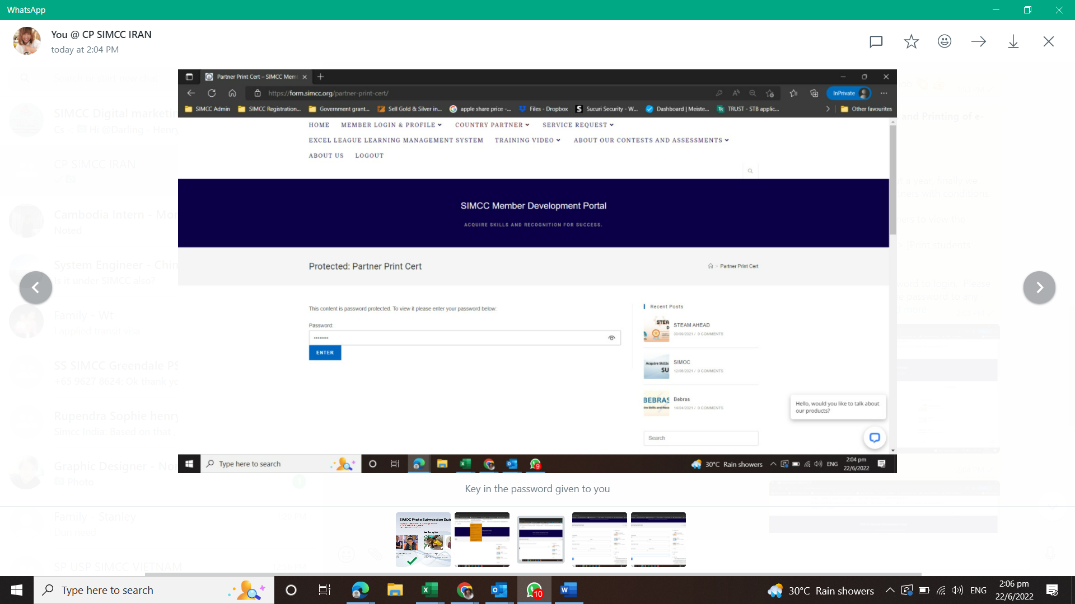
Key in the password given to you
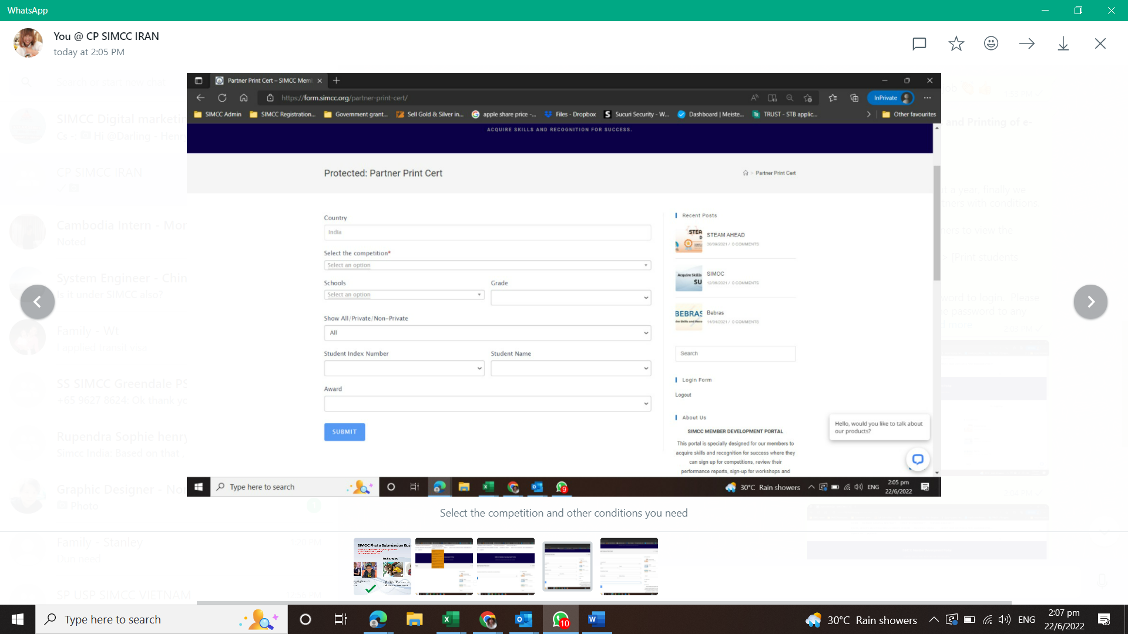
Select the competition you would like to query as well as other filters
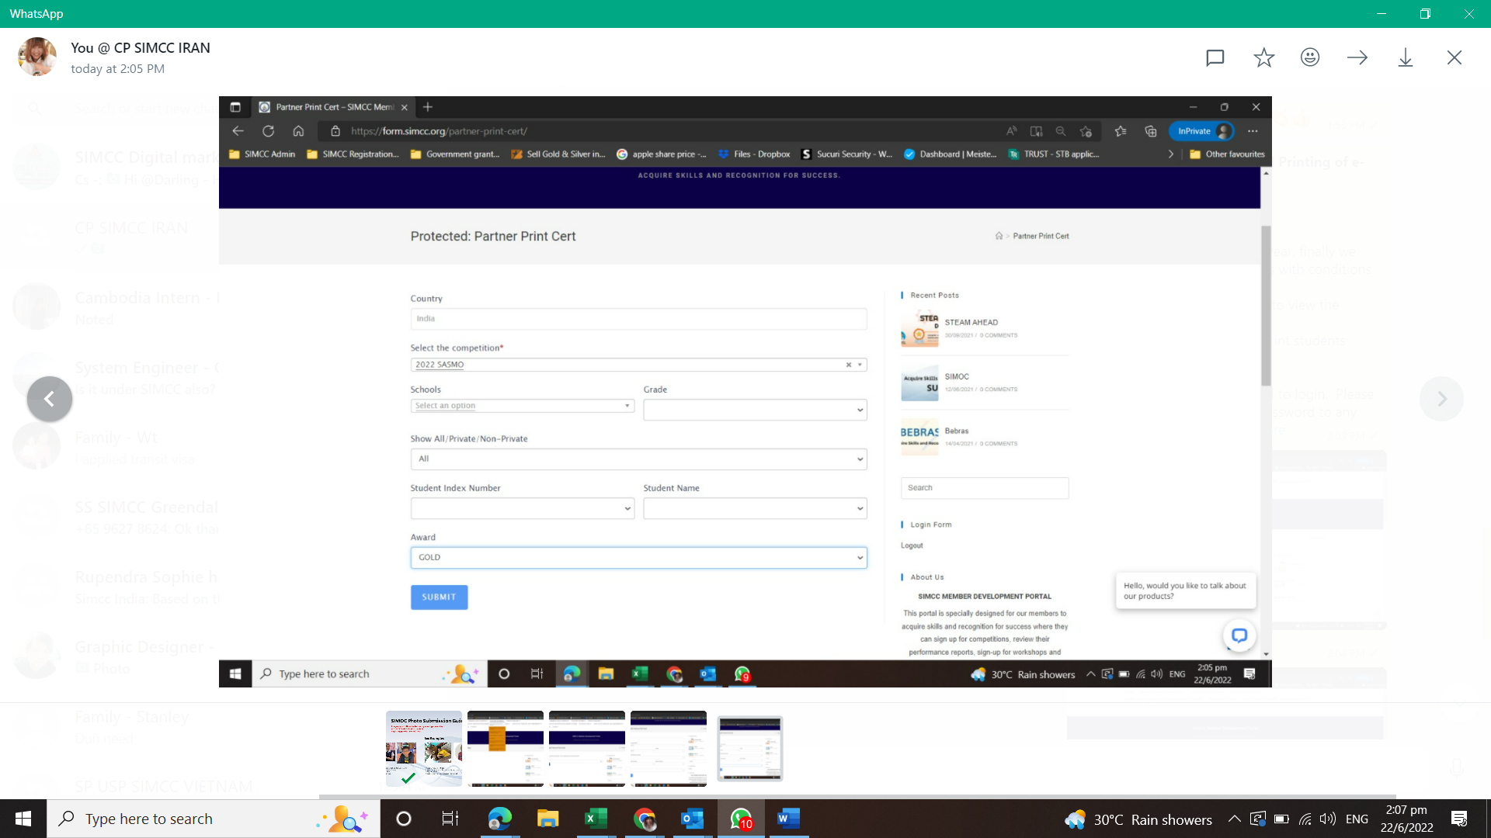
Example, if you would like to look at the results for SASMO 2022 and Gold award students.
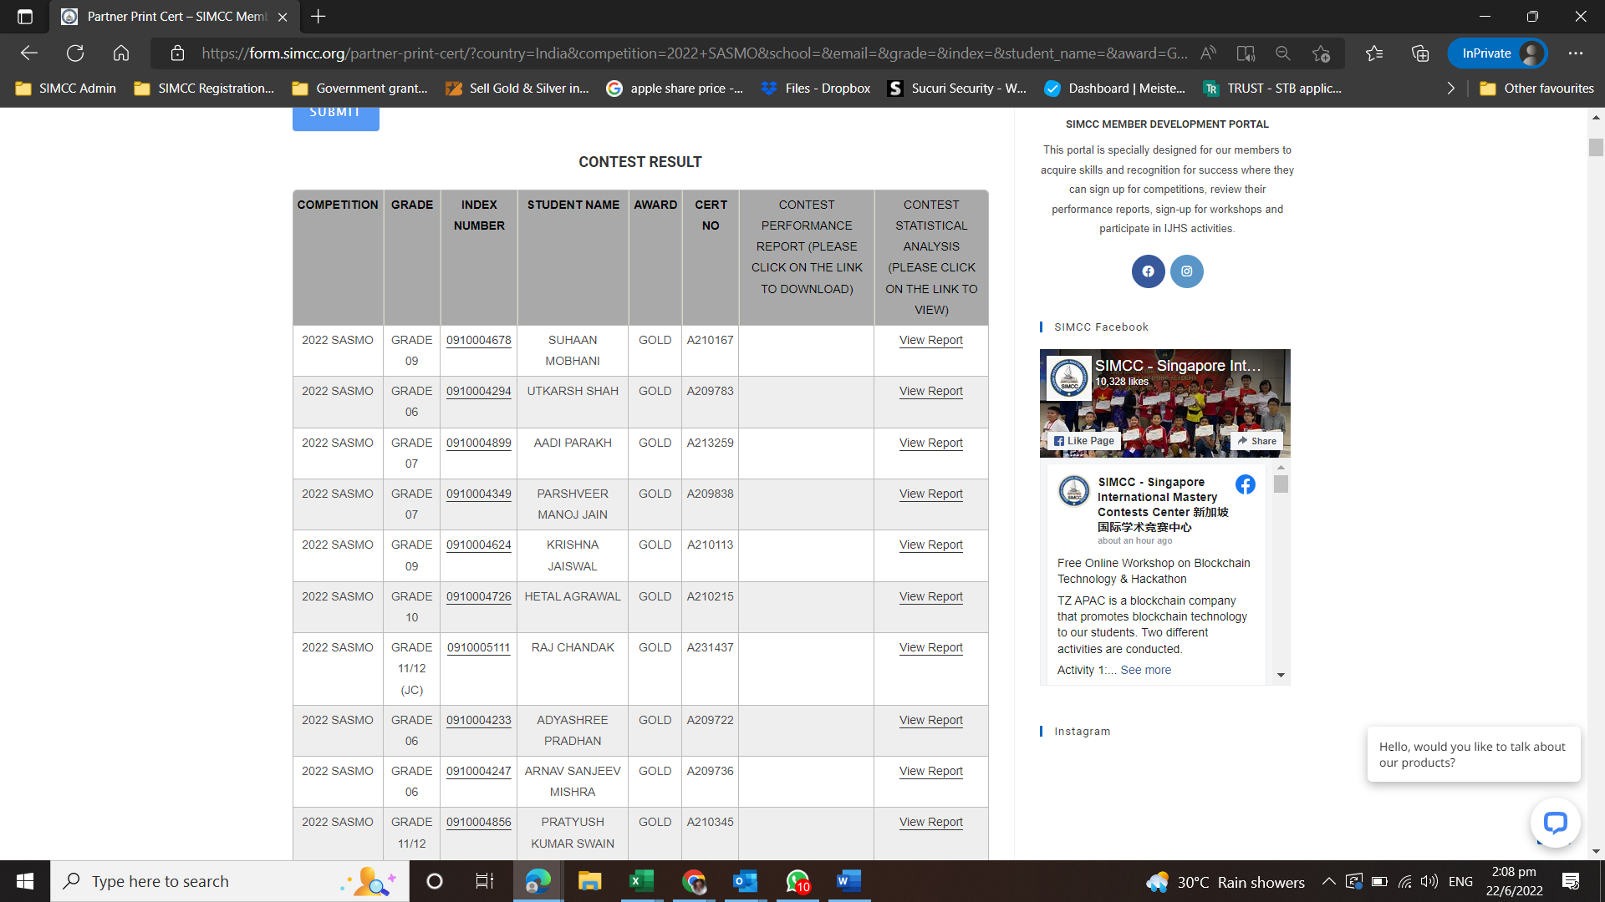
Once you click on the [Submit] button, the student summary will appear
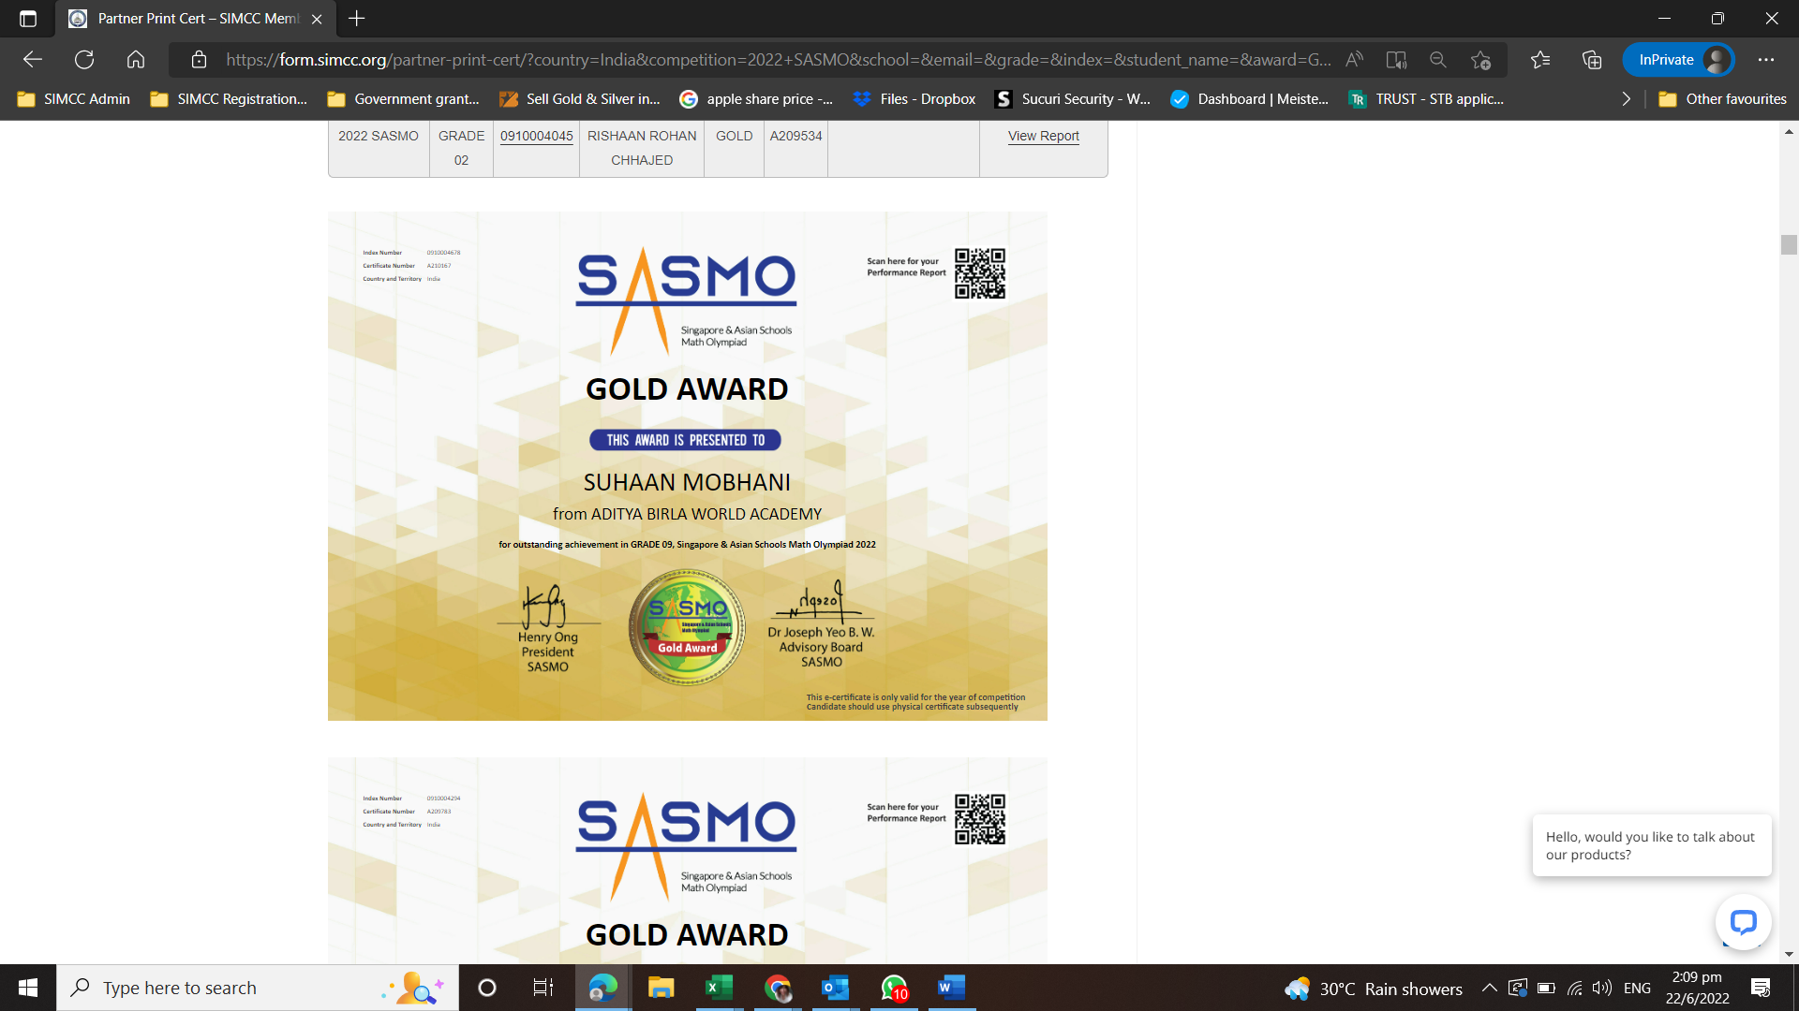
The student certificates will also be listed below.
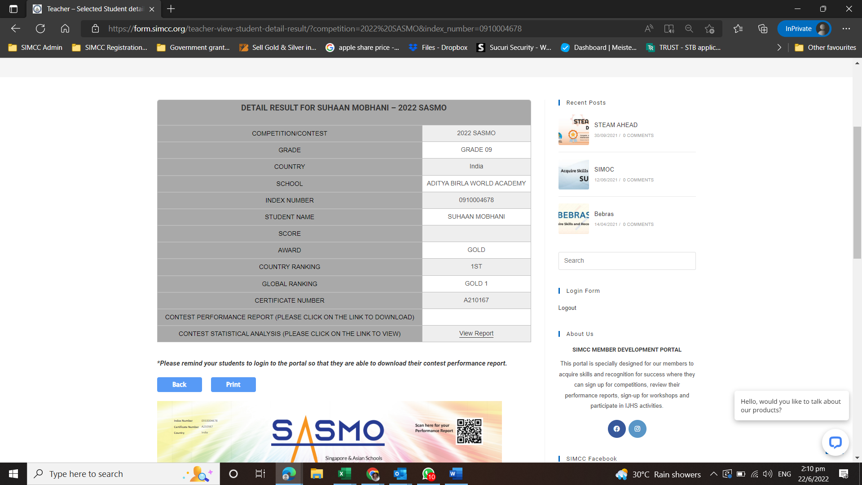
You can click on one of the students index number to view the individual result and the certificate.
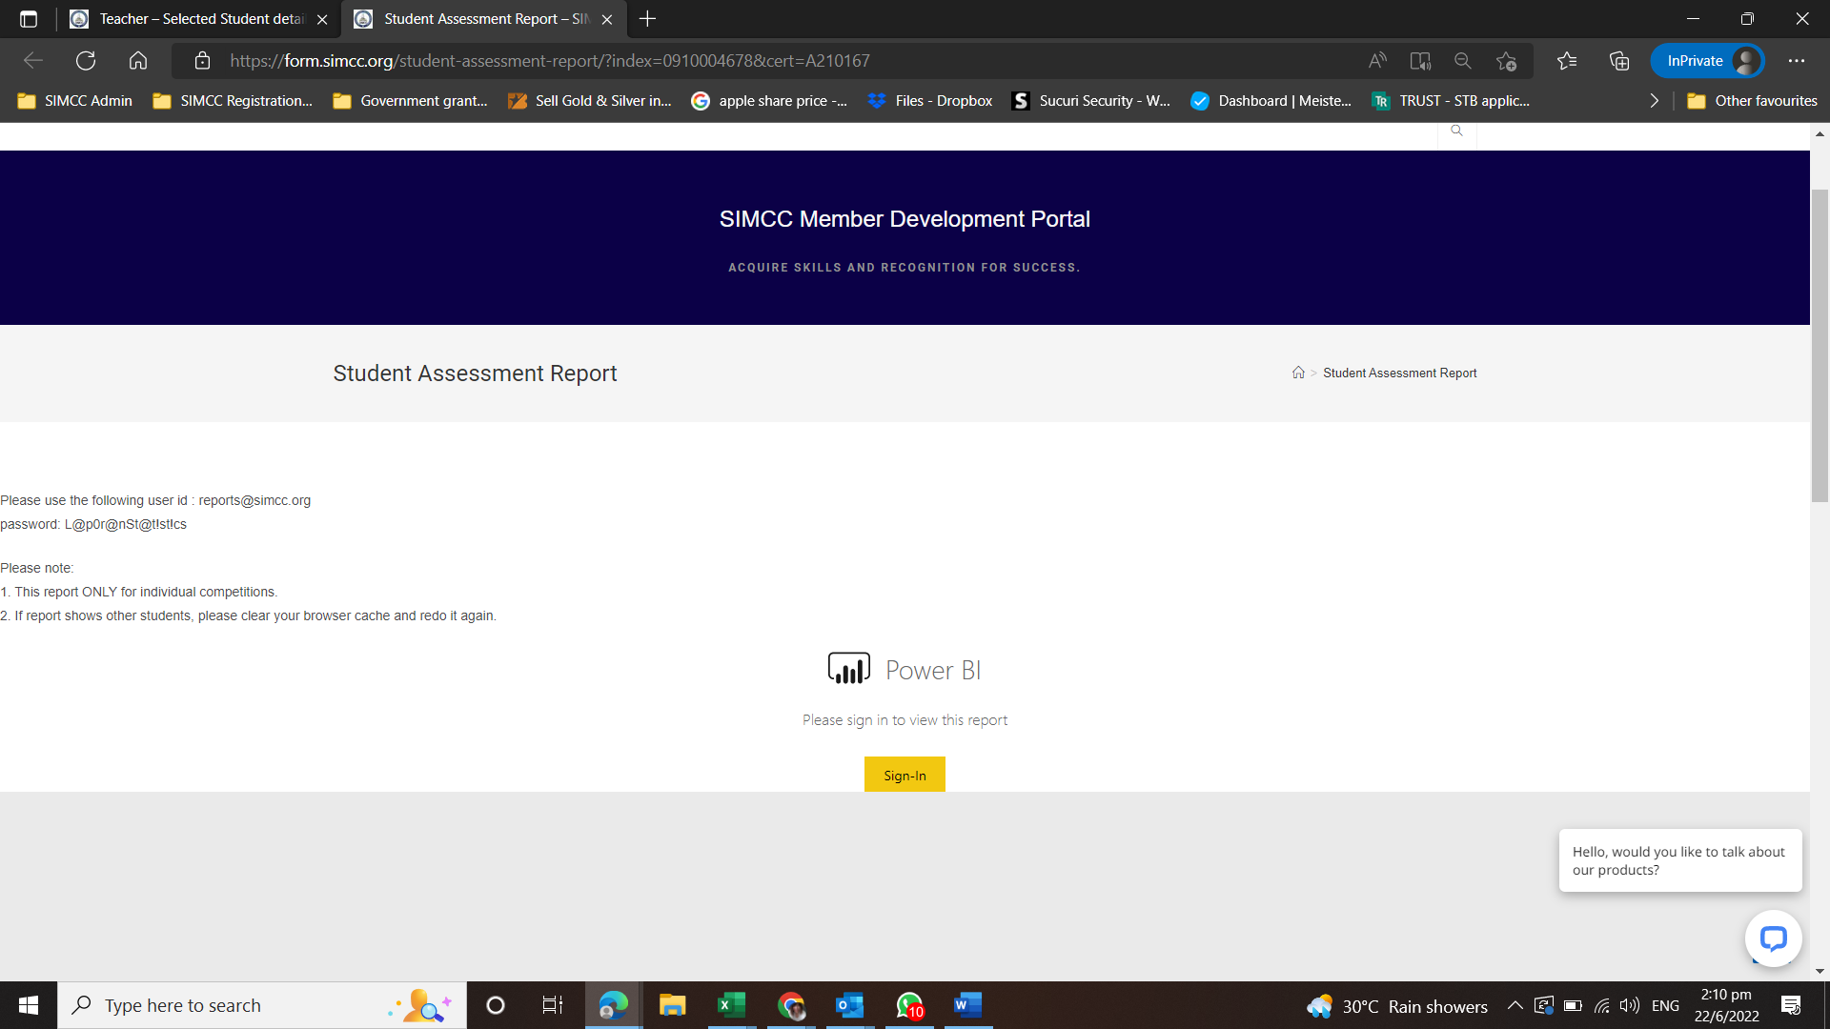
Click on the [View Report] link will allow you to see the student’s statistic.
Click on [Sign-in] button. Take note on the username and password given to you here on this page.
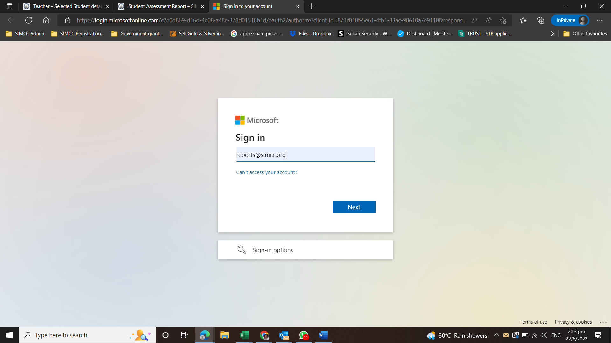
Type in the username given to you on the page.
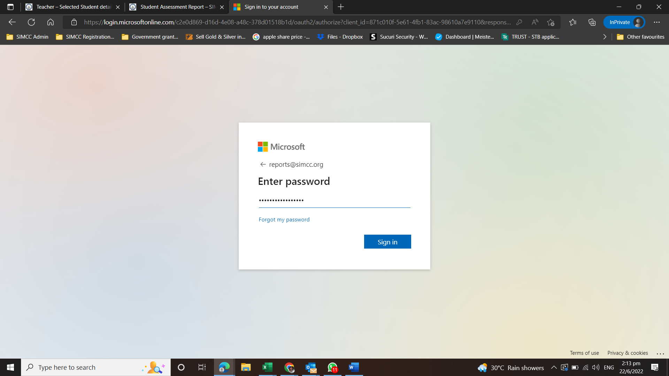
Key in the password given to you on the page.
Click on [Sign in] button.
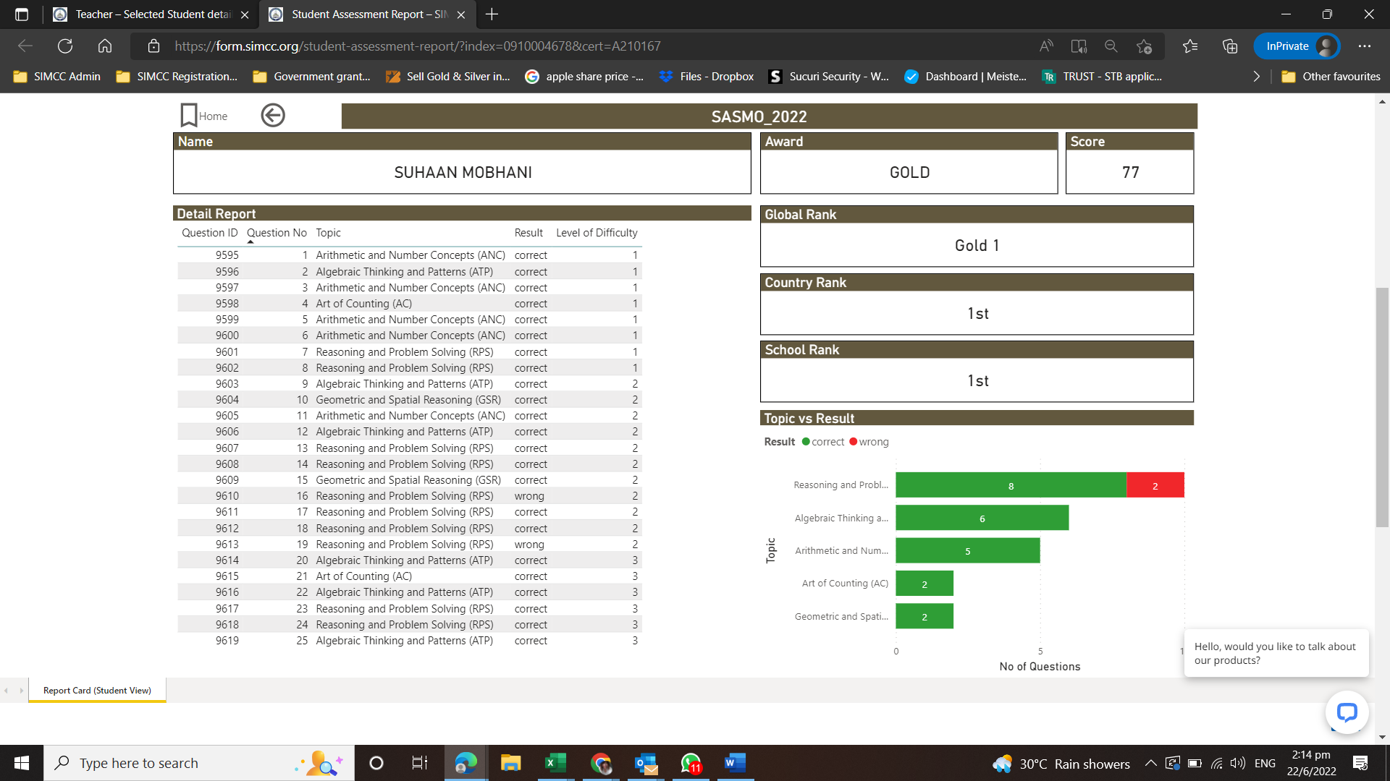
You will be able to see the student’s interactive report.
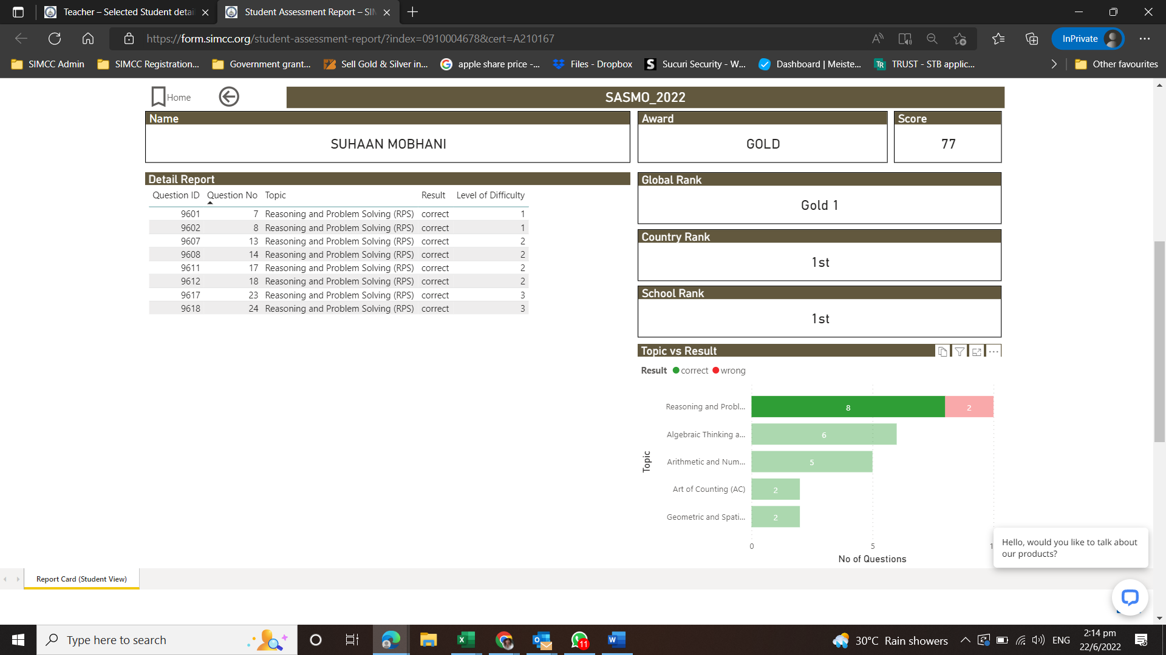
Click on the topic and correct will bring you to questions that are correct for that topic.
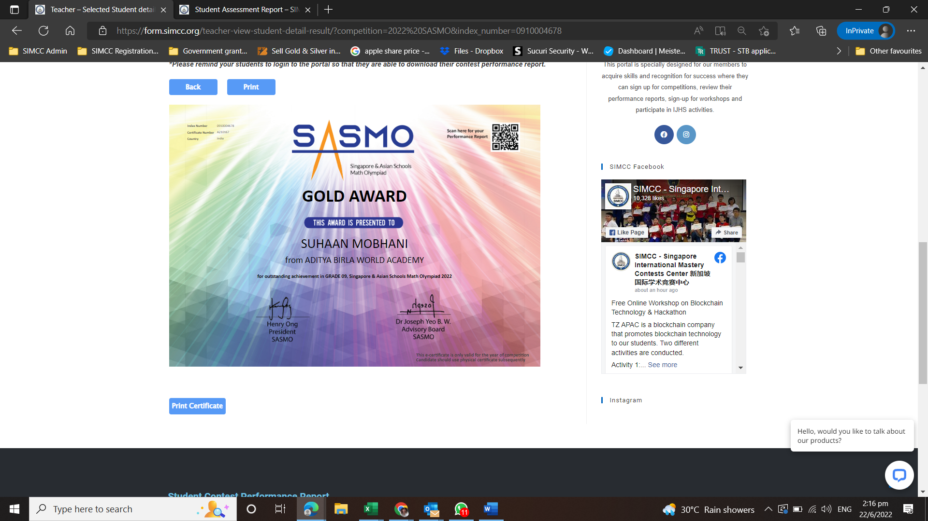
To print the cert for individual student, click on print certificate button.
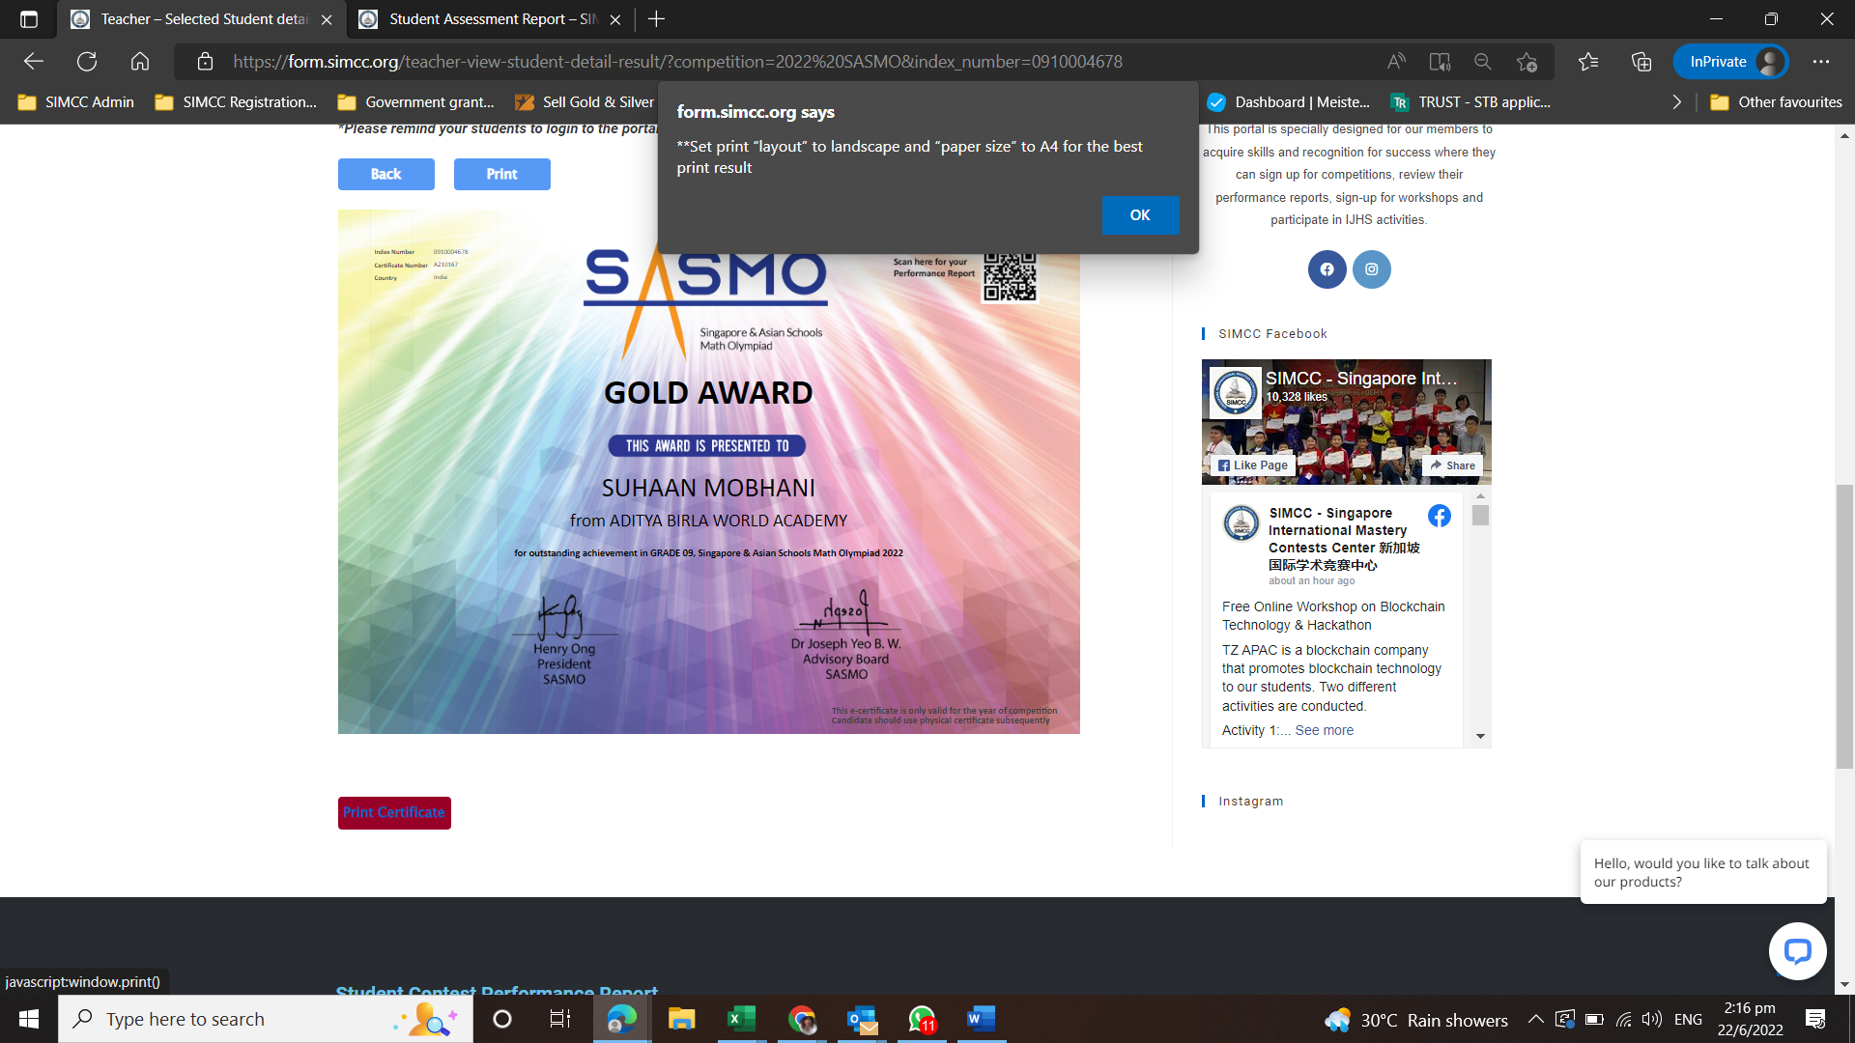
Please make sure you set the printing format correctly.
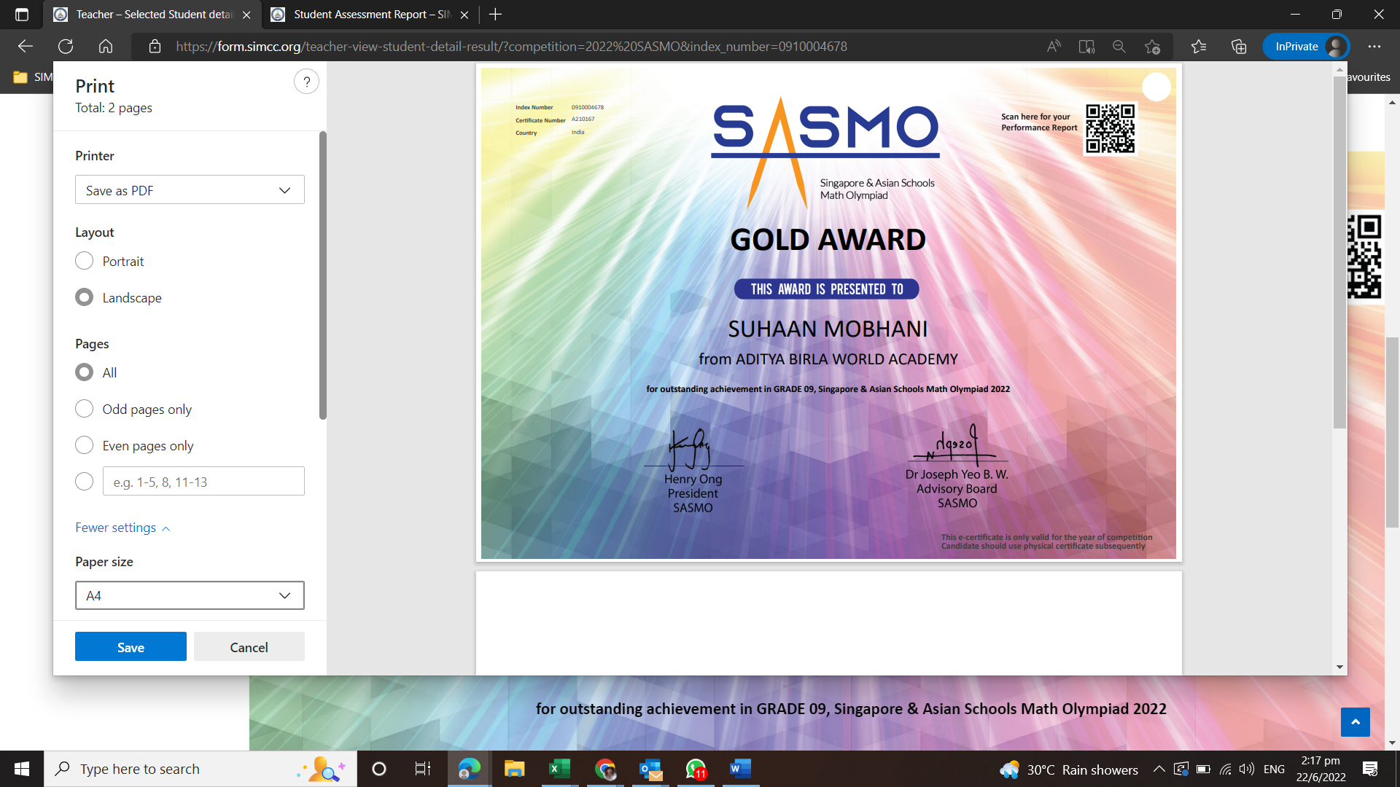
You can save the certificate in PDF file and sent to the student or print it later.

